

Databases

Charles Henderson



March 17, 2019

CST-235

Jackson

Charles Henderson

3/11/2019

5a: Test Database

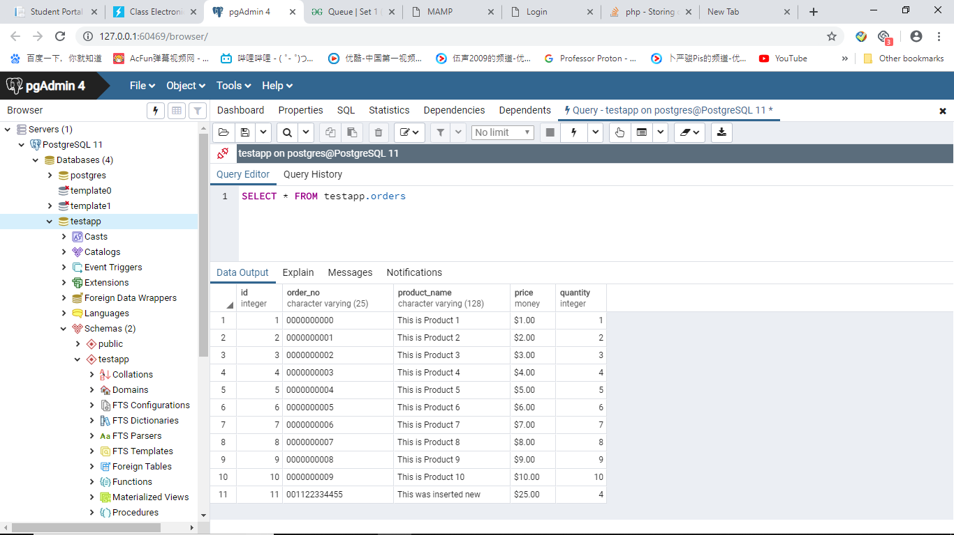

5b: Server Output

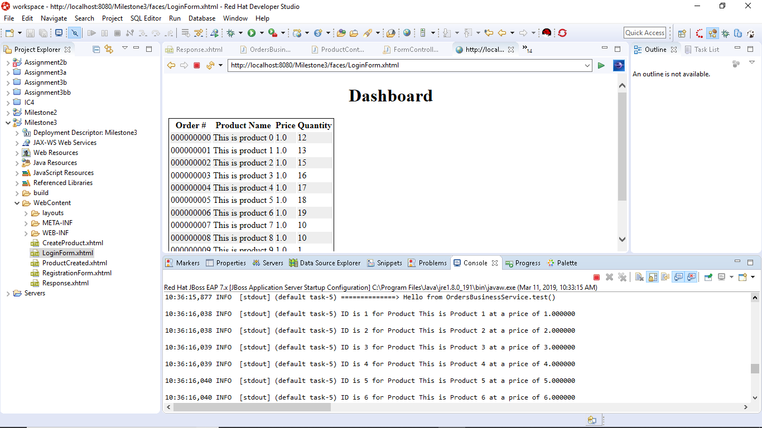

5d: Server Connection Message

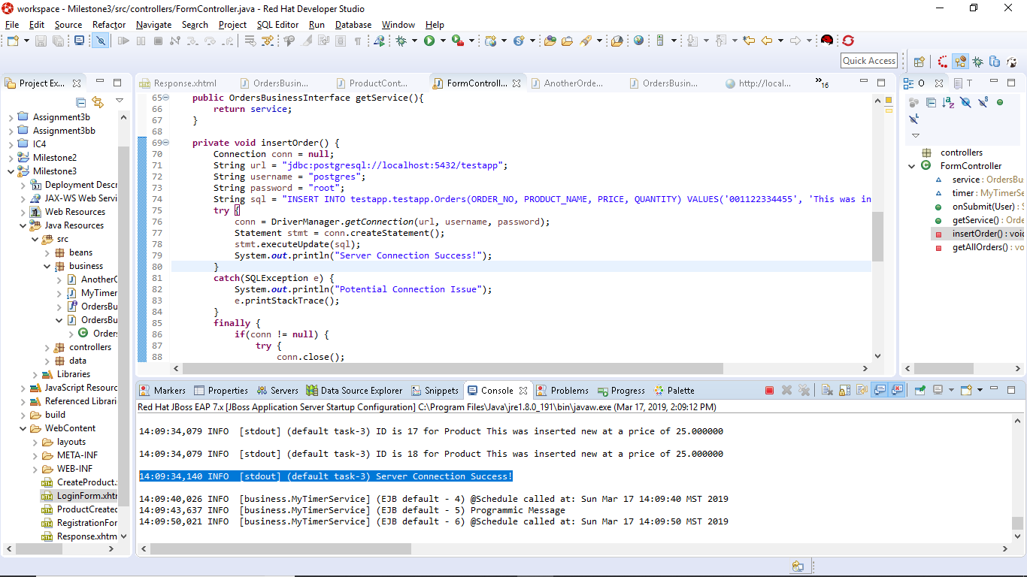

5d: Refactored getAllOrders()

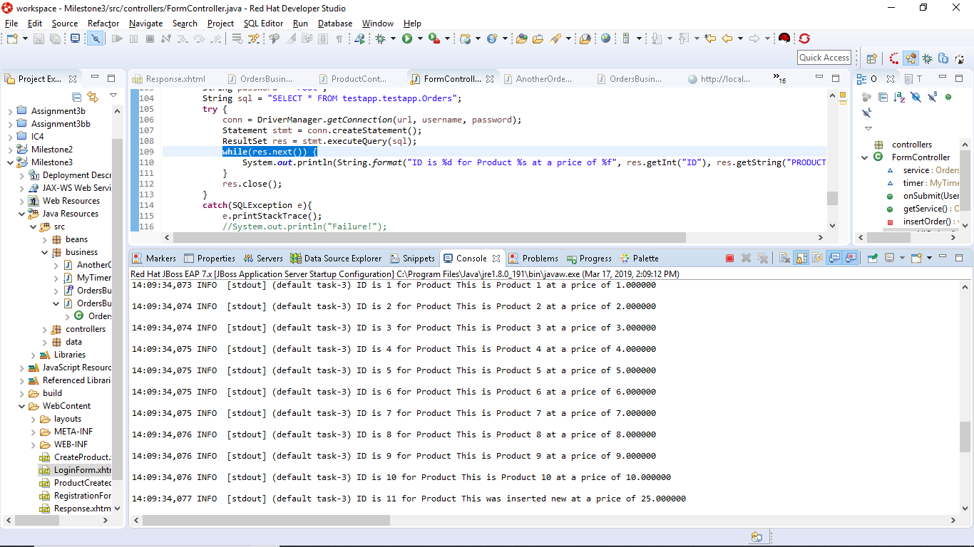

5e: insertOrder() (I’ve done this several times in testing so there are a lot of the same input)

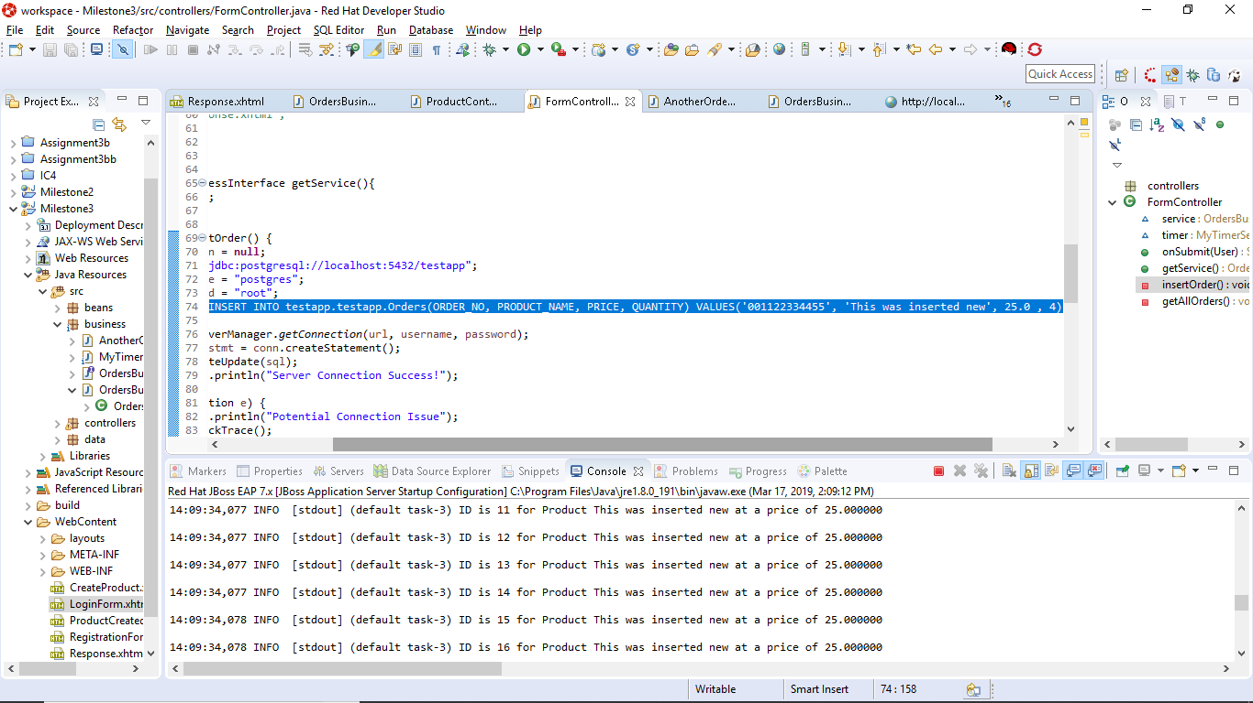

5f: Here is everything tabulated with updated ID column

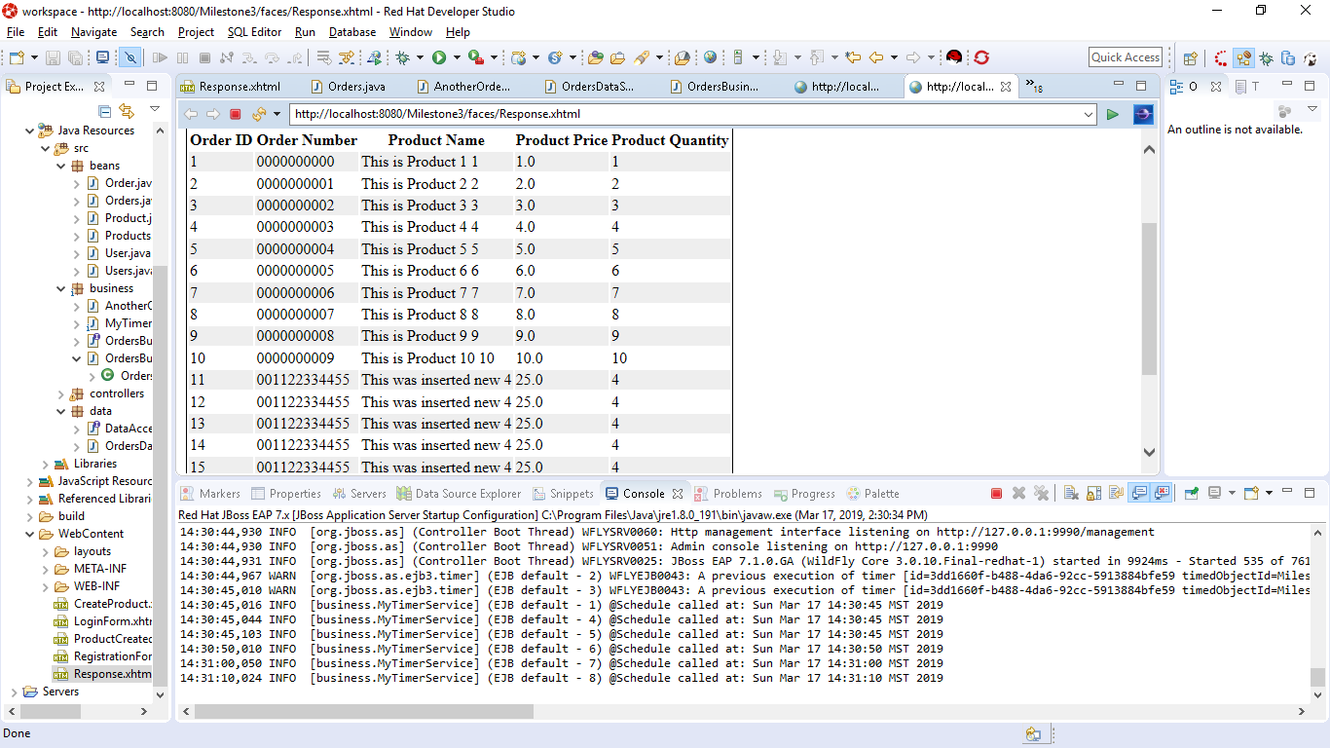

5f: Attempted findbyID method

